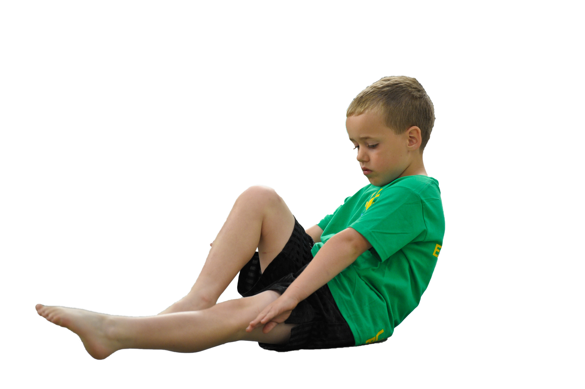
Schools must use the funding to make additional and sustainable improvements to the quality of Physical Education, Sport and Physical Activity (PESPA) they offer. This means that you should use the Primary PE and Sport Premium to:

- Develop or add to the PESPA activities that your school already offer
- Build capacity and capability within the school to ensure that improvements made now will benefit pupils joining the school in future years

Please visit gov.uk for the revised DfE guidance including the 5 key indicators across which schools should demonstrate an improvement. This document will help you to review your provision and to report
your spend. DfE encourages schools to use this template as an effective way of meeting the reporting requirements of the Primary PE and Sport Premium.

We recommend you start by reflecting on the impact of current provision and reviewing the previous
spend. Under the Ofsted Schools Inspection Framework, inspectors will assess how effectively leaders use the Primary PE and Sport Premium and measure its impact on outcomes for pupils, and how effectively governors hold them to account for this.

Schools are required to publish details of how they spend this funding as well as on the impact it has on pupils’ PE and sport participation and attainment by the end of the summer term or by 31 July 2019 at the
latest.
We recommend regularly updating the table and publishing it
on your website throughout the year, as evidence of your
ongoing review into how you are using the money to
secure maximum, sustainable impact. To see an
example of how to complete the table please
click HERE.

Support for review and reflection - considering the 5 key indicators from DfE, what development needs are a priority for your setting and your students now and why? Use the space below to reflect on previous spend, identify current need and priorities for the future.

Key achievements to date: | Areas for further improvement and baseline evidence of need:
Termly staff CPD sessions on Dance, Tri Golf and Outdoor Education  Nominated and awarded; Teignbridge Community Sports School of the Year 2018.  Bearnes have competed in the Teign Valley Inter League Tournament for Year 3, 4, 5 and 6. The Year 3 and 4 team came second overall missing out on the trophy by 1 point.  Bearnes have participated in The Link Academy Sports Festivals throughout the year providing children with an opportunity to participate in sports in purpose built facilities, which has helped inspire the children to an even greater extent.  Swimming lessons were opened up to Year 3 & 4 as well continuing with Year 5 & 6 which is an improvement on previous years. This meant that children had access to swimming earlier on in their education.  School Sports Week – Linking in with our 5 Star Pledge of meeting inspirational people and also contributing to the community by raising money for charity.  KS1 specific sports festivals led by Dynamic Sports throughout the year which gave our children an opportunity to develop children’s team work and fundamental movement skills.  Playground Leaders – Sports Leader provision is now fully established and embedded into our lunchtime routine with our leaders taking responsibility for games and tournaments. They have also been utilised during KS1 festivals to represent the school.  Two sports clubs per term have been provided throughout the year by sports coaches. | To ensure 2 hours of P.E. is consistently being completed each week by all teaching staff.  For teaching staff to develop their P.E. teaching by team teaching with specialist teacher; Matt Tanner in academic year of 2020/2021.  To celebrate sporting achievements of children outside of school as well as school based sport.  For EYFS to benefit from more sports provision across the year by holding an EYFS event day.  To include a KS1 event day during the year.

Meeting national curriculum requirements for swimming and water safety | Please complete all of the below:
What percentage of your current Year 6 cohort swim competently, confidently and proficiently over a distance of at least 25 metres?  N.B. Even though your children may swim in another year please report on their attainment on leaving  primary school. | 65%
What percentage of your current Year 6 cohort use a range of strokes effectively [for example, front crawl, backstroke and breaststroke]? | 65%
What percentage of your current Year 6 cohort perform safe self-rescue in different water-based situations? | 50%
Schools can choose to use the Primary PE and Sport Premium to provide additional provision for swimming but this must be for activity over and above the national curriculum requirements. Have you used it in this way? | No

Action Plan and Budget Tracking
Capture your intended annual spend against the 5 key indicators. Clarify the success criteria and evidence of impact that you intend to measure to evaluate for students today and for the future.

Academic Year: 2019/20 | Total fund allocated: £16,780 | Date Updated:
Key indicator 1: The engagement of all pupils in regular physical activity – Chief Medical Officer guidelines recommend that primary school children undertake at least 30 minutes of physical activity a day in school |  |  |  | Percentage of total allocation:
 |  |  |  | 30%
School focus with clarity on intended impact on pupils: | Actions to achieve: | Funding allocated: | Evidence and impact: | Sustainability and suggested next steps:
Saints Southwest P.E. Specialist teaching once a week.  Children to actively participate and engage in weekly P.E.lessons improving their ability.  At least two after school clubs provided per term to cater for EYFS/KS1 and KS2 alternately.  Daily Mile and/or Go Noodle/Wake Up Shake up sessions in class. | Implement rolling programme for Link Academy into Bearnes P.E. timetable.  S.L. to liaise with Matt Tanner and Coach Ben to run weekly P.E. sessions with Teacher support.  Half termly Staff CPD sessions to be organised by S.L. led by Saints Southwest to upskill staff members.  S.L. to lead alternative After School Club and Saints Southwest to provide sports provision across the whole school.  Implement in all classes daily. | £5000 | Teaching sessions that have been enjoyed by children and staff members working with Coach Ben.  ‘Saint of the week’ certificates given out in assembly.  Saints Southwest Sports Board.  Children are more engaged and motivated in P.E. lessons.  In a student interview about P.E. provision children said they enjoyed the different lessons and they think it’s improved because they have been able to do different sorts of sports.  Another student told us that they enjoyed doing P.E. this year because they’ve done more things and the lessons have been really fun.  The staff and pupils liked taking part in the different tournaments because they were fun and it got them doing things they’d never tried before.  DPA to encourage interest in fitness, health and good lifestyle choices. | Wake Up Shake up to be implemented across the whole school on a daily basis.
Key indicator 2: The profile of PESSPA being raised across the school as a tool for whole school improvement |  |  |  | Percentage of total allocation:
 |  |  |  | 0%
School focus with clarity on intended impact on pupils: | Actions to achieve: | Funding allocated: | Evidence and impact: | Sustainability and suggested next steps:
Sports Board  Annual Sports Week to be held to inspire and motivate pupils to participate in physical activity.  Linking with 5 star pledge to meet an inspiring individual, contribute in the local community.  Community Day – Exercis-a-thon  Weekly Sports Awards/ Sports Achievements to be announced and celebrated in school.  Playleader’s selected, rotated and monitored by M.R. to develop leadership skills. | Board with pictures from the year’s sports event to be on display.  Sports successes inside and outside of school to be put on display and put on the school website and Facebook page.  Class teachers to inform S.L. of children in their class who have had a significant achievement outside of school.  Teachers to photograph and email photos to S.L. to put on P.E. board  Sports Week planned and implemented in Summer term.  . | N/A | Regular posts have been put on Facebook. There has been a greater engagement from parents and outside sports groups as a result praising the children’s efforts. Children have an increased pride in their school.  Sports Week with increased focus on fundraising and supporting charities.  School was visited by a professional athlete and Atlantic Rowing team. Children were really inspired to meet them.  Exercis-a-thon raised profile of the school in the community whilst meeting one of our 5 star pledges. Children were energised and enthusiastic to have supported local charities. | Continued use of Facebook posts to keep profile of sport high.  To provide a Sports Week that links in with our 5 star pledge. The children were inspired to meet professional athletes and with the pre existing link we have will mean we can continue with our P.E. drive.  S.L. and K.Y. to work to raise profile of sports outside of school and celebrate children’s achievements outside of school.  Ply leader MTA nominated to oversee and model as needed.

Key indicator 3: Increased confidence, knowledge and skills of all staff in teaching PE and sport |  |  |  | Percentage of total allocation:
 |  |  |  | 15%
School focus with clarity on intended  impact on pupils: | Actions to achieve: | Funding  allocated: | Evidence and impact: | Sustainability and suggested  next steps:
Staff CPD  Staff Paediatric First Aid Award  P.E. assessment spreadsheet to monitor progress.  Improved technology to aid and support the teaching of high quality P.E. lessons. | S.L. to liaise with Saints Southwest and Academy Heads to schedule P.E. CPD into staff meetings.  S.L. to attend a Paediatric First Aid course.  S.L. to demonstrate how to complete P.E. assessment spreadsheet and to check in with staff to support with completing assessment grid.  Staff and children able to reflect and demonstrate key skills. | (already accounted for under Saints provision)  £200  None  £2200 | P.E. CPD events scheduled into the calendar.  Increased confidence of teachers in the leading of P.E.lessons.  S.L. successfully completed Paediatric First Aid course – to be renewed in 3 years time.  Assessment grid completed for all children by teachers and Coach Ben.  Teaching monitored and improved, children using this to reflect on our outcomes, technique and to improve these. | CPD sessions to be scheduled at the beginning of the year to allow enough time for M.T. and teachers to prepare.  Assessment grid to be continued by all staff as a monitor for progress in sports and help identify G & T.  Ongoing personal CPD for staff and skill improvement for pupils. Progres seen but this to be embedded into weekly lessons.
Key indicator 4: Broader experience of a range of sports and activities offered to all pupils |  |  |  | Percentage of total allocation:
 |  |  |  | 8.5%
School focus with clarity on intended  impact on pupils: | Actions to achieve: | Funding  allocated: | Evidence and impact: | Sustainability and suggested  next steps:
Additional achievements:  KS1 Festivals  KS2 Orienteering Day  Transport to Sports Competitions  After School Clubs – Ensure at least 2 extra-curricular sports activities are provided every school term. Students are to become more confident in sports activities’ and to increase student participation in sport. | S.L. to liaise with T.R and Tim Flint of Dynamic Sports to confirm dates and arrange transport from Bearnes to venue.  S.L. to compile an event table with location, date, tournament information, number of children required, packed lunch required etc for the whole year and transport to be booked and arranged in September for the scheduled events with support from T.R.  letter template for teachers to complete available on Google Drive for teachers to access and send out to their pupils for events relevant to their class.  MT to continue to offer this as SSW did. | £200  £450  £700 | During conferences with children they have shared the view that they enjoyed visiting other schools and taking part in different actitivites.  The day the KS1 Festival was held at Bearnes we used our playleaders to help lead the sessions, which boosted their confidence and self esteem and we had positive feedback from other teachers in the other schools.  KS2 Orienteering day was enjoyed and helped by having plenty of adults and volunteers supporting the children. It was nice to link with a forest school art activity for the half the day.  High participation in sports clubs with waiting lists, this is not always the case but the enthusiasm to take part has been undeniable. | To continue using the sports events document to make organisation of transport etc easier and more manageable for P.E. lead, office administrators and class teachers.  Ensure that at least 9 adults can attend to ensure the children get the most out of the day.  It was really good to get KS2 to do the day altogether instead of splitting the transport. It made it really fun for them as they experienced a range of things on one day.  MT to continue to offer this as SSW did.
Key indicator 5: Increased participation in competitive sport |  |  |  | Percentage of total allocation:
 |  |  |  | 5%
School focus with clarity on intended  impact on pupils: | Actions to achieve: | Funding  allocated: | Evidence and impact: | Sustainability and suggested  next steps:
Saints Southwest Link Academy Tournaments.  Teign Inter Valley League – Year 3 & 4 and Year 5 & 6 Inter Valley League.  Transport to Sports Events | S.L. to liaise with class teachers to selected teams for events and organise letters and lunches etc.  S.L. to liaise with office staff to organise transport. | £360  £500 | Children have really enjoyed representing their school. They have an increased sense of pride and their accomplishments and achievements are recognised in assembly.  Year 3 & 4 came second in the league missing out by just 1 point. | Tim Flint is organised and names venues early to make organisation easier for class teacher and P.E. lead.  For inter valley tournaments it is only a group of 6-8 that go which makes it easier to staff.  Look to use a overarching risk assessment for all of Tim Flints events to save on paperwork only changing for specific needs.  EVOLVE training for all staff

