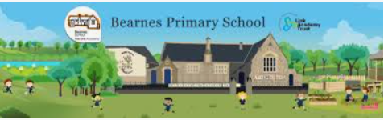

Writing Curriculum Plan Year 1 and 2 Year B

Year A | Autumn |  |  | Spring |  |  | Summer
Progression of Core Texts | Text: |  |  | Text: |  |  | Text:
Progression of Core Texts | Mixed Up Fairy Tales  Fiction | Tell me a Dragon  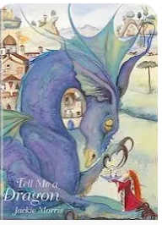  Poetry | Slime Book  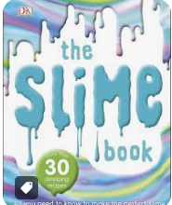  Non-Fiction | The Story Path  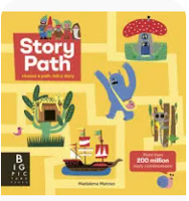  Fiction | Look Inside Space  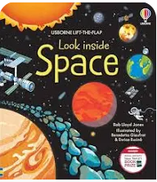  Non-Fiction | The Book of Hopes  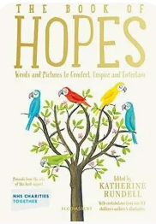  Fiction | A Hidden World of Oceans  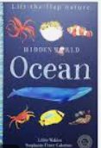  Non-Fiction | Knock Knock  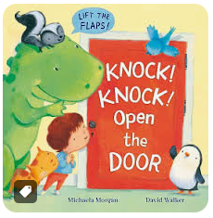  Fiction | The Train Ride  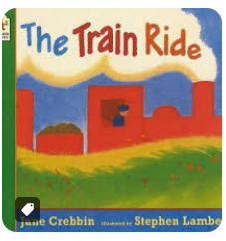  Poetry
Progression of Core Texts | Key Outcome: |  |  | Key Outcome: |  |  | Non-Fiction
Progression of Core Texts | Narrative  To write (or orally create) their own short fairy tales in parts using as part of an whole class book of mixed up fairy tales. | Poetry  Make individual ‘Tell me a Dragon’ book. | Instructions  To write instructions for making a new Slime recipe. | Narrative  To write own story based on decisions made within the text that teaches. | Non-Chronological Report  To write a double page spread of information which includes an introduction, a flap with sentences providing further information for the reader and a flap which poses and answers a question. | Narrative  An account of a pocket-sized toy’s adventure in a human-sized world | Information Book  To contribute sentences/pages to a class lift-the-flap book about animals or plants of a particular environment/habitat, e.g. rainforest, pond, local area | Narrative  To write a new Knock Knock book. | Poetry  Write a ‘journey’ story with a clear sequence of events in the style of ‘The Train Ride’
Year 1 | Combining words to make single clause sentences ( oral first)  Simple sentences and spaces  between words  Punctuating using capitals and full stops. | Write sentences by saying out loud what they are going to write about. Composing sentences orally before writing them.  Learning to appreciate rhymes and poems and to recite some by hear. | saying out loud what they are going to write about  composing a sentence orally before writing it  leaving spaces between words  joining words and joining sentences using ‘and’ | sequencing sentences to form short narratives  Punctuating using capitals and full stops.  re-reading what they have written to check that it makes sense  expanded noun phrases to describe and specify [for example, the blue butterfly]  subordination  (using when, if, that, or because) and co-ordination (using or, and, or but) | joining words and clauses/sentences using and  beginning to punctuate sentences using a capital letter and a full stop, question mark or exclamation mark  sequencing sentences to form short narratives  re-reading what they have written to check that it makes sense | leaving spaces between words  beginning to punctuate sentences using a capital letter and a full stop, question mark or exclamation mark  using a capital letter for names of people, places, the days of the week, and the personal pronoun ‘I’. | joining words to make sentences and joining words and clauses/sentences using and  beginning to punctuate sentences using a capital letter and a full stop, question mark or exclamation mark | Leave spaces between words.  Join words and joining clauses using and.  Begin to punctuate sentences using a capital letter and a full stop, question mark or exclamation mark. | Write sentences by saying out loud what they are going to write about.  Composing sentences orally before writing them.  Learning to appreciate rhymes and poems and to recite some by hear.
Year 2 | Sentences with capital letters and correct punctuation  Multi clause sentence work – Coordination recap from year 1 ( include but )  Subordination introduction | Expanded Noun Phrases  Prosody and performance  Alliteration  Rhyme and rhythm  Refrains and repeating patterns | Sentence types: commands ( exclamations and questions)  Multi clause sentence work – Coordination and  Subordination  Verb choices (Imperative for commands)  Expanded nouns to describe and specify  Adverbs | Past simple tense and present simple tense  Multi clause sentence work – Coordination and  Subordination  Apostrophe for contraction and possession ( apply from SPAG)  Expanded noun phrases ( commas) | Sentence types and choice  Multi clause sentence work - Coordination  Subordination  Commas in lists  Expanded noun phrases  Present simple and present  progressive tense ( verb choice)  Presentation and layout | Present simple and present  progressive tense (Verb  Choice )  Multi clause sentence work - Coordination  Subordination  Commas in lists  Expanded noun phrases | Sentence types: commands  Multi clause sentence work - Coordination  Subordination  Suffix -ly for adverbs  Presentation and layout  Common prepositions | Multi clause sentence work - Coordination  Subordination  Expanded noun phrases  Commas in lists  Suffix -ly for adverbs  Verb choices and tense choice | Expanded Noun Phrases  Prosody and performance  Alliteration  Rhyme and rhythm  Refrains and repeating patterns

Block 1  Lessons  1- 15 | Block 1  Lessons  16 - 30 | Block 2  Lessons  1 - 15 | Block 2  Lessons  16 - 30 | Block 3  Lessons  1-15 | Block 3  Lessons  16 - 30 | Block 4  Lessons  1-15 | Block 4  Lessons  16 - 30 | Block 5  Lessons  1-15 | Block 5  Lessons  16 - 30 | Block 6  Revision  Lessons | Block 6  Revision  Lessons

No Nonsense Grammar Strands for reference
Grammar and punctuation  No Nonsense Grammar  YEAR ONE | Strand 1a 1 2 3  Simple Sentences  What’s in a picture  Sentence work  .Hammer those verbs  Verbs  Stop  Orally/ with an action:  Full stops  Capitals | Strand 1a 4 5  Simple Sentences  Silly sentences  Sentence work  Sort it.  Likes and dislikes  Using and  Assess Sentence work | Strand 1b 1 2 3  Subordination and co ordination  Likes and dislikes  Using and  Physical sentences  Using and  What’s in picture?  Using and  Orally/with an action  Full stops  Capitals | Strand 1c 1  Sentences  Playing with Sentence types  Full stops  Question marks  Exclamation marks | Strand 2  Nouns and noun phrases  All in a name  Nouns  Plurals  Grammar goggle s  Nouns  Plurals | Strand 2 reinforcement Strand 3 Adverbials  Where is  Common prepositions - where | Strand 2  Nouns and noun phrases  Describe the object  Noun phrases  Understanding opposites  Prefix un | Strand 4  Verbs  Sort it  Identifying verbs  Verb bingo  Identifying verbs  Past and present  Tense – ing ed | Strand 3  Adverbials  When did.  Common prepositions – when | Strand 4  Verbs  Adding ed  Ing and ed  Silly sentences  Assess past and present verbs | Recap and assess | Recap and assess
Grammar and punctuation  No Nonsense Grammar  YEAR TWO | Strand 1b 4 5 6  Sentences  Fill the slots  Punctuation  Question it  Questions | Strand 1c  Sentences2,3,4  Sort it  Punctuation: full stops,  Commands,  exclamations, questions and Capitals  Physical sentences  and, or, but  Subordinating with physical sentences  when, if, that, because  Using that  That | Strand 2  Nouns and noun phrases  Revise nouns  Nouns  Expanding nouns  Noun Phrases  and modification and commas  Playing with pronouns.  Pronouns | Strand 1c 5,6,7  Sentences  Do as I tell you  Commands  How tricky is this?  Exclamations  More exclamations  Exclamations | Strand 2  Nouns and noun phrases  Noun phrases  Noun phrases  Determiners and commas  All about apostrophe  Possession and plurals  Adjective overload  Noun phrases  Commas  Determiners  apostrophes | Strand 2  Nouns and noun phrases  I went to the market  Noun phrase  Adjective comma  A web of words  Suffixes  Word combinations  Compounding | Strand 4  Verbs  Hammer those verbs  Past and present  What are you doing?  Past and present  All in agreement  Present progressive verbs | Strand 3  Adverbials  How do you do?  Using adverbs  . Try it out.  Pre modifying adverbs  Advise and instruct  Adverbs to add detail in instructions | Strand 3 Adverbials  Collecting adverbs  adverbs  Adjectives to adverbs  Adjectives and adverbs  Transform  Suffix ly/adverb  Physical sentences  Using adverbs | Strand 4  Verbs  Simple to progressive  Present progressive  Tense sorting/ choices  Tenses  Assessment | Recap and assess | Recap and assess
Spelling  No Nonsense Spelling | Block 1  Lessons  1- 15 | Block 1  Lessons  16 - 30 | Block 2  Lessons  1 - 15 | Block 2  Lessons  16 - 30 | Block 3  Lessons  1-15 | Block 3  Lessons  16 - 30 | Block 4  Lessons  1-15 | Block 4  Lessons  16 - 30 | Block 5  Lessons  1-15 | Block 5  Lessons  16 - 30 | Block 6  Revision  Lessons | Block 6  Revision  Lessons
Handwriting | Year 1 & 2 handwriting focus:  All pupils will learn to write in print using the correct letter formation before transitioning to cursive handwriting – if they are ready and forming all letters correctly.  All pupils will use diagonal strokes to join their writing in a legible.  All pupils will engage in daily handwriting for at least the first half of the Autumn Term.  All pupils will have at least one implicitly taught handwriting lesson each week.  All pupils will use wider lines to support their writing.  All pupils will write with a sharp pencil.

