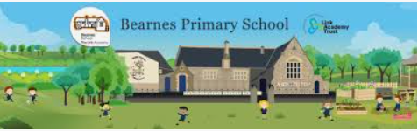

Writing Curriculum Plan Year 3 and 4 Year B

Year A | Autumn |  |  | Spring |  |  | Summer
Progression of Core Texts | Text: |  |  | Text: |  |  | Text:
Progression of Core Texts | An anthology of Animals  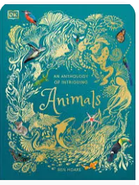  Non- Fiction | Lord of the Forest  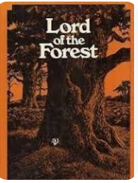  Fiction | Flotsam  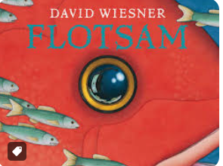  Fiction | Interview with the tiger  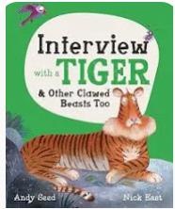  Non- Fiction | Jack and the Dreamsack    Fiction | Carry Me Away  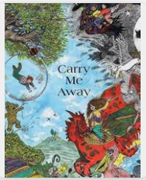  Poetry | Cinderella of the Nile  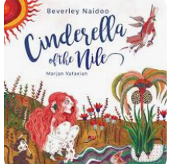  Fiction | Fantastically Great Women Who Changed The World  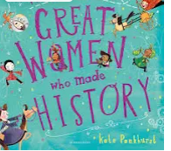  Non-Fiction | Leon and the Place Between  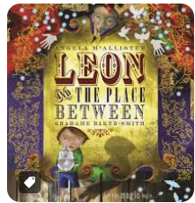  Fiction
Progression of Core Texts | Key Outcome: |  |  | Key Outcome: |  |  | Non-Fiction
Progression of Core Texts | Information Text  To write an information text about 3 different animals organised in a specific way (or contribute to group or class book about animals). | Narrative  To write own story using the pattern of the text. | Description  To write part of the story of Flotsam including a detailed description of one of the settings. | Information Text  To create your own ‘Interview with…’ (could be an animal, person or even inanimate object). | Narrative  To write own voyage and return fantasy story based on Jack and the Dream Sack. | Poetry  Write a poem about a chosen animal using some of the poetical devices explored. | Narrative  Write a new version of Cinderella, including a different setting and ‘back story’ to the original. | Biography  To write a biography of a famous person, choosing elements of layout, presentation and language to match the chosen personality and their achievements. | Narrative  All children to create their own versions of Leon’s story from the point the portal is reached.
Year 3 | Orally compose sentences – saying out loud what they want to write. Recap of single clause sentence- subject verb, noun.  Recap of multiclause sentence using a conjunction (Y2) | Use of capital letters, full stops, question marks and exclamation marks (Yr2)  Commas to separate items in a list (Yr2)  Compose and rehearse sentences orally (including dialogue), building a rich and varied vocabulary and an increasing range of sentences (Yr3/4)  Expressing place using prepositions (yr3) | Using conjunctions (e.g. when, before, after, while, so, because), adverbs (e.g. then, next, soon, therefore) and prepositions (e.g. before, after, during, in, because of) to express time, place and cause (Y3) | Begin to use direct speech.  Using conjunctions (e.g. when, before, after, while, so, because), adverbs (e.g. then, next, soon, therefore) and prepositions (e.g. before, after, during, in, because of) to express time, place and cause (Y3)  Assessing the effectiveness of their own and others’ writing and suggesting improvements. | In narratives, create settings, characters and plot.  Y3: Expressing time, place and cause using conjunctions (e.g. when, before, after, while, so, because), adverbs (e.g. then, next, soon)and prepositions (e.g. before, after, during, in, because of) | Proof-read for spelling and punctuation errors.  Read aloud their own writing, to a group or whole class, using appropriate intonation and controlling the tone and volume so that meaning is clear – oracy. | Introduction of paragraphs as a way to group related material (Y3)  Using the present perfect form of verbs instead of the simple past tense (Y3) | Headings and subheadings to aid presentation (Y3)  Using conjunctions (e.g. when, before, after, while, so, because), adverbs (e.g. then, next, soon, therefore) and prepositions (e.g. before, after, during, in, because of) to express time, place and cause (Y3). | Use and punctuate direct speech.  Introduction of paragraphs as a way to group related material (Y3)  In narratives, create settings, characters and plot.
Year 4 | Appropriate use of pronoun or noun within and across sentences to aid cohesion and avoid repetition.  Extending the range of sentences with more than one clause by using a wider range of conjunctions, including when, if because, although.  composing and rehearsing sentences orally (including dialogue), progressively building a varied and rich vocabulary and an increasing range of sentence structures.  Introduction of paragraphs as a way to group related material (Y3). | Compose and rehearse sentences orally (including dialogue), building a rich and varied vocabulary and an increasing range of sentences (Yr3/4) | Using conjunctions (e.g. when, before, after, while, so, because), adverbs (e.g. then, next, soon, therefore) and prepositions (e.g. before, after, during, in, because of) to express time, place and cause (Y3)  Using fronted adverbials (Y4).  Noun phrases expanded by the addition of modifying adjectives, nouns and preposition phrases (eg; the teacher expanded to the strict maths teacher with curly hair) (Y4) | Use direct speech.  Noun phrases expanded by the addition of modifying adjectives, nouns and preposition phrases (e.g. the teacher expanded to the strict maths teacher with curly hair) (Y4)  Assessing the effectiveness of their own and others’ writing and suggesting improvements. | In narratives, create settings, characters and plot.  Using fronted adverbial. (Y4) | Proof-read for spelling and punctuation errors.  Read aloud their own writing, to a group or whole class, using appropriate intonation and controlling the tone and volume so that meaning is clear – oracy. | Use of paragraphs to organise ideas around a theme (Y4)  Using commas after fronted adverbials (Y4) | Headings and subheadings to aid presentation (Y3)  Standard English forms for verb inflections instead of local spoken forms (e.g. we were instead of we was or I did instead of I done) (Y4)  Noun phrases expanded by the addition of modifying adjectives, nouns and preposition phrases (e.g. the teacher expanded to the strict maths teacher with curly hair) (Y4) | Use and punctuate direct speech.  In narratives, create settings, characters and plot.  Use of paragraphs to organise ideas around a theme (Y4)

No Nonsense Grammar Strands for reference
Grammar and punctuation  No Nonsense Grammar | Strand 1b  Coordination and subordination  What’s in a sentence  Joining clauses  Fill the punctuation | Patterning sentences  Uncovering meaning/ Transform it,  Strand 1 c  Sentence types  Who said it? | Sorting Sentence types  Strand 2 Nouns and Noun phrases  What do determiners do?  a/an  Adjective overload! | Nonsense phrases  Happy families  It’s mine | Follow my thread  Build it  Strand 3  Adverbials  Adverbial slots | Where am I?  When does this happen?  Transform it! | More about adverbials  Sort it!  Creating physical sentences | Assess | Strand 4 verbs  Perfectly formed sentences  Changing tenses  What does it do? | Assess and recap | Assess and recap | Assess and recap
Spelling  No Nonsense Spelling – Year 3 | Revise  Suffixes from Year 2 (‘-s’, ‘-es’, ‘-er’, ‘-ed’, ‘-ing’)  Revise  prefix un-’  Teach prefix ‘dis-’  (disappoint, disagree, disobey)  Revise  From Year 2: Apostrophes for contractions  Teach  Rarer GPCs: words with the /eɪ/ sound spelt ‘ei’ (vein), ‘eigh’ (eight), ‘aigh’ (straight) or ‘ey’ (they)  Teach  Homophones (brake/break, grate/great, eight/ate, weight/wait, son/sun) |  | Revise  Statutory words learnt last half term  Strategies at the point of writing: Have a go  Revise  Homophones  Revise Year 2 prefixes and suffixes  Teach  Prefixes ‘mis-’ and ‘re-’  Teach  The /ɪ/ sound spelt ‘y’  Teach  Proofreading  Teach  Words ending with the  /g/ sound spelt ‘-gue’ and the /k/ sound spelt ‘-que’ (French in origin) |  | Revise  From Year 2: suffixes  ‘-ness’ and ‘-ful’ following a consonant  Teach  Prefixes ‘sub-’ and ‘tele-’  Practise  From Year 2: apostrophe for contraction  Teach  Words with the /ʃ/ sound spelt ‘ch’ (mostly French in origin) as well as ‘s’, ‘ss(ion/ure’)  Revise/Teach  Revise suffixes ‘-ness’ and ‘-ful’  Teach  suffixes ‘-less’ and ‘-ly’ |  | Teach  Prefixes ‘super-’ and ‘auto-’  Teach  Strategies at the point of writing: homophones  Revise Proofreading  Teach  Words with the /k/ sound  spelt ‘ch’ (Greek in origin) |  | Revise  Previously taught suffixes (‘-ed’, ‘-ing’, ‘-s’, ‘-es’,  ‘-ness’, ‘-ful’, ‘-less’ and ‘-ly’)  Teach  Suffix ‘-ly’ with root words ending in ‘le’ and ‘ic’  Revise  From Year 2: Apostrophes for contractions  Teach  Rare GPCs (/ɪ/ sound)  Revise  From Years 1 and 2: vowel digraphs |  | Revise  Strategies at the point of writing: Have a go Spellings learnt in the last half term  Teach  The /ʌ/ sound spelt ‘ou’  Teach  Homophones (including heel/heal/he’ll, plain/plane, groan/grown and rain/rein/ reign)  Teach  Proofreading
Spelling  No Nonsense Spelling – Year 4 | Revise  Strategies for learning words: words from statutory and personal spelling lists  Teach  Words ending /ʒə/  Teach  Year 2: possessive apostrophe with singular proper nouns  Teach:  Homophones |  | Revise  Strategies for learning words: words from statutory and personal spelling lists  Teach  Proofreading  Teach  Prefixes ‘in-’, ‘il-’, ‘im-’ and ‘ir-’  Revise  Words with the /eɪ/ sound spelt ‘ei’, ‘eigh’ or ‘ey’ Words with the /ʃ/ sound spelt ‘ch’ and the /ʌ/ sound spelt ‘ou’  Teach  Adding suffixes beginning with vowel letters to words of more than one syllable (‘-ing’, ‘-er’, ‘-en’, ‘-ed’) |  | Teach  The /g/ sound spelt ‘gu’  Teach  Words with endings sounding like /tʃə/ spelt ‘-ture’  Teach  Possessive apostrophe with plurals  Teach  Homophones (scene/seen, mail/male, bawl/ball)  Learn  Strategies for learning words: words from statutory and personal spelling lists |  | Assess  Statutory spellings learnt so far  Teach:  Proofreading  Teach  Prefixes ‘anti-’ and ‘inter-’  Teach  Endings that sound like  /ʃən/ spelt ‘-cian’, ‘-sion’,  ‘-tion’ and ‘-ssion’  Practise  Strategies for learning words: words from statutory and personal spelling lists  Revise  Spellings taught so far |  | Teach  Words with the /s/ sound  spelt ‘sc’ (Latin in origin)  Learn  Strategies for learning words: words from statutory and personal spelling lists  Strategies at the point of writing: Have a go  Teach  Endings that sound like  /ʒən/ spelt ‘sion’  Revise  Apostrophes for possession, including singular and plural  Teach  Homophones  Revise  Statutory words learnt during the year |  | Teach  Suffix ‘-ous’  Practise  Proofreading  Revise  Prefixes ‘un-’, ‘dis-’, ‘in-’,  ‘re-’, ‘sub-’, ‘inter-’, ‘super-’, ‘anti-’, ‘auto-’  Learn  Strategies for learning words: words from statutory and personal spelling lists  Teach  Suffix ‘-ly’ added to words ending in ‘y’, ‘le’ and ‘ic’  Assess  Words learnt so far
Handwriting | Year 3 & 4 handwriting focus:  All pupils will be expected to join their writing in a cursive and legible style.  All pupils will use a handwriting pen by the time they are in Year 4.  8mm lined books used to support writing.  Handwriting to be implicitly taught at least once a week using handwriting books.  All pupils will write with a sharp pencil.

