

**Bearnes Primary School Strategic Improvement Priorities**

**KEY IMPROVEMENT PRIORITIES for 2019-20**

**Key Priority 1**

**Quality of Education**

**We will focus on improving the teaching & learning challenge through forensic analysis reflected in improved progress data. This will focus on the progression of reading and spelling skills throughout the school.**

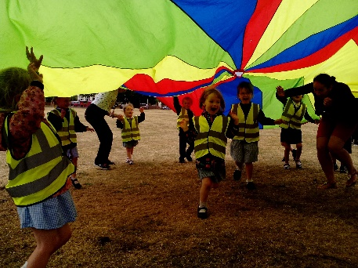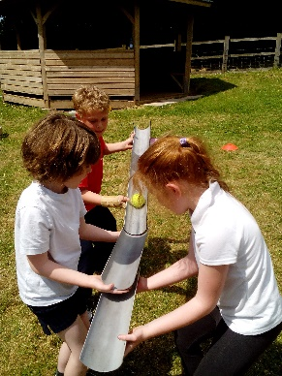[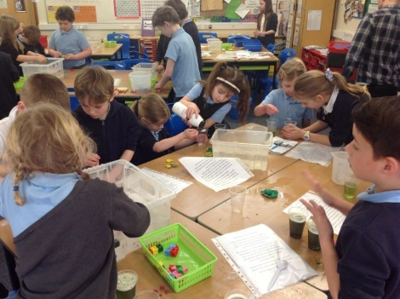](http://stokegabriel.thelink.academy/wp-content/uploads/2018/04/29261618_1969807423032709_5157668566106898432_o.jpg)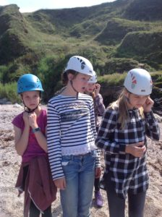

**Key Priority 6**

**Early Years**

**Expansion of our EY offer to work with families from a younger age, enhanced by high quality parent induction to Bearnes.**

**Key Priority 5**

**Personal Development, Behaviour and Welfare**

**As a whole school we will consider their impact of our actions on the local and wider community with particular focus on our 5 Star.**

**Key Priority 4**

**Leadership & Management & Quality of Education**

**Middle Leaders will engage with the Trust-wide network to ensure the highest quality delivery of a broad and balanced curriculum at Bearnes.**

**Key Priority 3**

**Quality of Education:**

**Computing**

**To provide a high quality computing curriculum and use IT, including i-pads, to enhance the teaching of all curriculum subject skills.**

**Key Priority 2**

**Quality of Education**

**Science**

**Science Curriculum planning, delivery & teaching is enhanced with a focus on ‘working scientifically’.**