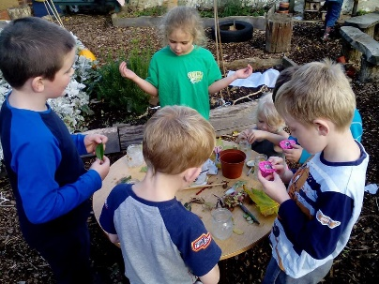 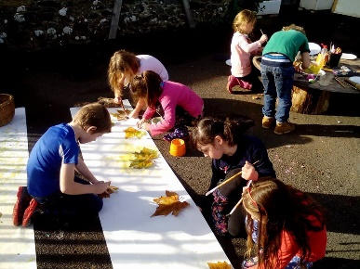

**Key Priority 1a**

**Outcomes for Pupils**

**Teaching and Learning**

*To be at or above national progress for reading, writing and maths with a focus on previous high attainers.*

**Bearnes Academy Strategic Improvement Priorities**

**KEY IMPROVEMENT PRIORITIES for 2018-2019**

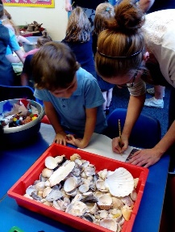 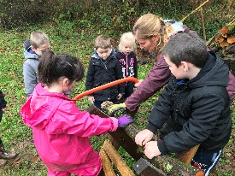 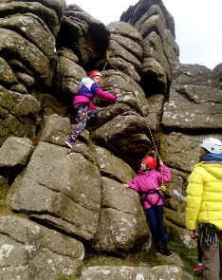

**Key Priority 5**

**Outcomes for pupils**

***Writing***

*To develop strategies around writer purpose and raise standards for our higher attaining writers*

**Key Priority 4**

**Personal Development, Behaviour and Welfare**

***Mental Health, Spirituality & Well-being***

*To raise the awareness of and act positively on issues surrounding mental health in pupils, staff and parents.*

**Key Priority 3**

**Teaching, Learning & Assessment**

***Curriculum***

*To develop a broad and balanced curriculum that caters for individual need and empowers pupils to tackle current world issues.*

**Key Priority 1b Outcomes for Pupils**

***Teaching and Learning***

*To develop skills in life long and independent learning for pupils to achieve personal potential.*

**Key Priority 2**

**Teaching, Learning and Assessment**

***Computing***

*To set up and deliver a well-resourced and maintained computing curriculum that ensures a broad and balanced delivery of skills and experiences for pupils*